LIFE CYCLE OF PEZIZA

By: For:
Dr Arun kumar singh B.Sc.(Part-I),Botany(S)
Associate professor in Botany Fungi
JLN College Dehri –on sone Paper-I
Gmail:-arunsinghbot85@gmail.com

__________________________________________________________________

Systematic position

Class :Ascomycetes

Order :Pezizales

Family :Pezizaceae

Genus :Peziza

Peziza is a discomycetous saprophytic fungus growing in plain during rain on varied nature of substrates including rotten logs, dungs, humus soil etc

Mycelium

It is well developed, frequently perennial and consists of a dense network of hyphae. The hyphae are branched septate and subterranean. The fruiting bodies are above ground. The cells are both uninucleate and multinucleate.

Reproduction :-
1. Asexual Reproduction:
It takes place by the formation of conidia and chlamydospores.
By Conidia :-
The conidia are exogenously formed spores. They are abstricted from the tips of conidiophores. Each conidium germinates to form a new mycelium.
By Chlamydospores :-
The chlamydospores are thick-walled resting cells. They are intercalary in position. They may be formed singly or in series within the cells of the hyphae. Under suitable conditions each chlamy-dospore germinates and gives rise to a new mycelium.
2. Sexual Reproduction:
Sexuality prevails in complete absence of sex organs. Here sexuality may be defined as the ‘act of fusion between the nuclei of compatible strains(+ and-), followed by meiotic division.
Specific ascogenous hyphae,responsible for the forming the asci and ascospores, originate due to act of somatogamy occurring between compatible hyphae
Recipient cell forms a dikaryon. A dikaryotic cell under goes repeated cell division (perhaps due to act of clamp connection) in order to form several dikaryotic cells.
The hypha, having several dikaryotic cells, is known as ascogenous hyphae.
Formation of ascus and ascospores.
The apical cell of ascogenous hypha forms a crozier showing conjugate division.The septation of crozier leads to the formation of a three celled structure -the terminal,basal and sub terminal cell;both the basal and terminal cells are monokaryotic while the subterminal cell dikaryotic.
Karyogamy in subterminal cell results in formation of diplont(2n)nucleus. It acts as an ascus mother cell.Ascus mother cell elongates and by three successive division it forms eight haplont nuclei in linear order.
The accumulation of cytoplasm around all nuclei transforms them as ascospores. Eight ascospores in linear order are produced per ascus.
Formation of ascocarp.
With the formation of several asci parallel to one another, the constitute the upper surface of fru ctification while the somatic mycelia form the body of fructification .Interspersed between the asci are the Sterile hyphae called paraphyses. The rest of the apothecium consists of densely interwoven, branched hyphae forming a pseudoparenchymatous tissue which supports the hymenium .
Ascocarp cup or saucer shaped, sessile. They are white or buff-coloured. The apothecia are sessile or shortly stalked cup-shaped structures regular in form and large in size varying from 2 cm. to several inches in diameter. In P. vesiculosa the apothecium is of pale fawn colour but P. aurantia has brilliant orange apothecium
Liberation and germination of ascospores.
In moist condition,asci form apical opening through which ascospores liberates;they aredisseminated byair.In cotact with suitable substratum,they germinate directly by putting

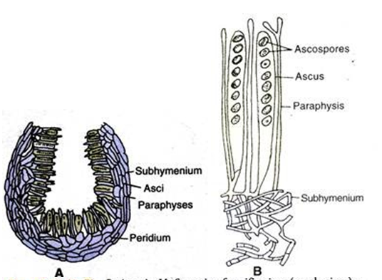

Peziza A. V.S. of an apothecium(diagrammatic) B. V.S. of a part of apothecium

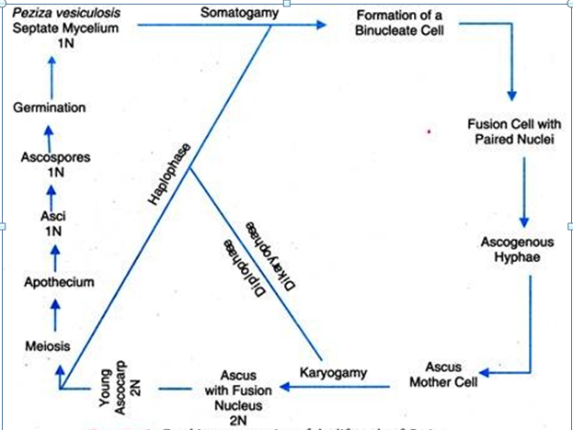
Peziza :Life cycle by words

